AROMNI
WHITE PAPER
Building the Internet of Everything
Connecting the Real, Data, Augmented, Digitally Twinned and Virtual Worlds
2026

1. Executive Summary
Aromni (to be renamed YSpatial) is building the Internet of Everything (IoE) — a spatial computing infrastructure connecting the Real World and the Data World through Smart Tags, Hypergraph Data Structures, and Augmented Reality Interfaces.
Derived from YDreams' two decades of innovation in mixed reality — spanning 2,000+ projects with global clients including Coca-Cola, Disney, Microsoft, Samsung, and Benfica — Aromni fuses hardware, software, and network intelligence to create a seamless layer that allows anyone to browse, interact, and transact with the physical world as easily as they do with websites.
Aromni's technology is embodied in a set of proprietary modules — ARIA, ARP, ARDIS, and ARC — and a powerful IP portfolio covering mixed reality, IoE data models, hypergraph databases, and vertical applications in retail, sports, mobility, and smart cities.

Vision
"Just as Tim Berners-Lee gave humanity the World Wide Web, YSpatial gives it the World Wide World." — Aromni Manifesto

The platform is currently deployed in pilots with Jerónimo Martins, Benfica, and municipalities in Portugal, with a Series A of €5M targeting expansion across retail, smart cities, mobility, and the creator economy.

2. The Evolution of the Internet — Why the World Needs a Spatial Layer
For three decades, the Internet has revolutionized how we connect with information and each other. Yet it has remained fundamentally disconnected from the physical world we inhabit. Every building, street, product, and experience exists in reality but lacks a structured digital presence that can be browsed, queried, and transacted with as easily as a website.
Three converging forces are now making spatial computing the defining frontier of the next decade:

Era | Key Innovation | Dominant Medium | Core Limitation
Web 1.0 | Hypertext | Text + Images | Static content
Web 2.0 | Social Media & Mobile | Networks of users | Data silos
Web 3.0 | Blockchain | Tokens & Decentralization | Detached from physical world
Web 4.0 (Aromni) | Internet of Everything | Smart Tags bridging Real & Data Worlds | None — seamless interaction

Three Converging Forces
- Hardware Maturation: AR glasses from Meta, Apple, and others reaching consumer scale; 5G networks enabling real-time spatial data streaming; advanced sensors and computer vision becoming ubiquitous.
- Market Readiness: $300B+ AR/VR market projected by 2028; retail, cities, and enterprises seeking digital transformation beyond screens; consumer demand for contextual, location-aware experiences.
- Technological Foundation: 20+ years of YDreams innovation with 2,000+ projects; proprietary IP portfolio covering mixed reality and hypergraph databases; proven pilot deployments across major brands and municipalities.

3. Core Philosophy — From Real to Data and Back
The world consists of five interlinked layers that Aromni connects through its platform:
- Real World: Physical environments and experiences — the world as we perceive it.
- Data World: Digital representations of real entities — maps, sensors, records, databases.
- Augmented World: Layered information enhancing perception through AR overlays.
- Digitally Twinned World: Precise, manipulable digital counterparts of physical objects and spaces.
- Virtual World: Synthetic simulations for design, entertainment, education, and learning.

Aromni bridges these layers through Smart Tags (STAGs) — atomic data structures that carry identification, description, media, behavior, and interaction code. Each Smart Tag is a living data object that connects these worlds, forming the base unit of the IoE.

4. Core Technologies

4.1 Smart Tags (STAGs) — The Atomic Unit of the IoE
Smart Tags (STAGs) are the foundational building blocks of the Aromni platform. They are living data objects that connect physical entities to rich digital content, enabling two-way interactions across the real and digital worlds.
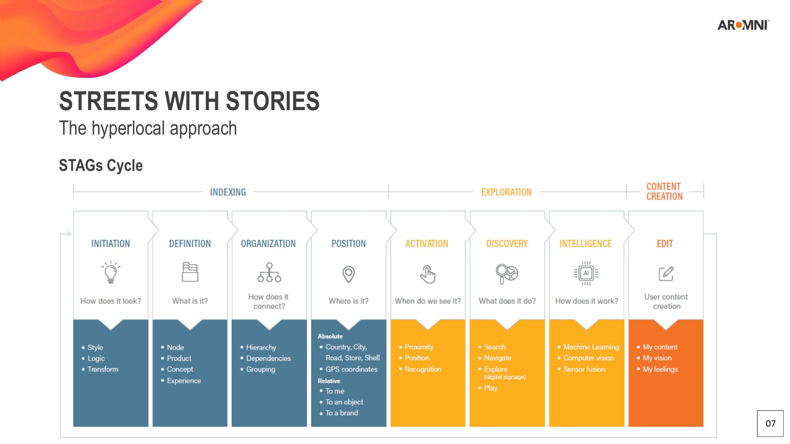
The STAG lifecycle — from Indexing to Exploration to Content Creation
- Connect physical entities to rich digital content (3D, AR, transactions, analytics)
- Enable two-way interactions: browse, share, purchase, co-create
- Form hypergraph networks that mirror real-world relationships
- Create measurable, tradable data assets for every place, object, and experience
- Support content types: Text, Audio, Image, Video, 360° (image & video), 3D models & animations, AR/VR experiences

STAGs are spatial structures that not only contain the content to be explored but also all the information about how and when they should be explored. Each STAG has a story within it, and STAGs can be related to one another, together composing a powerful and flexible exploration system.
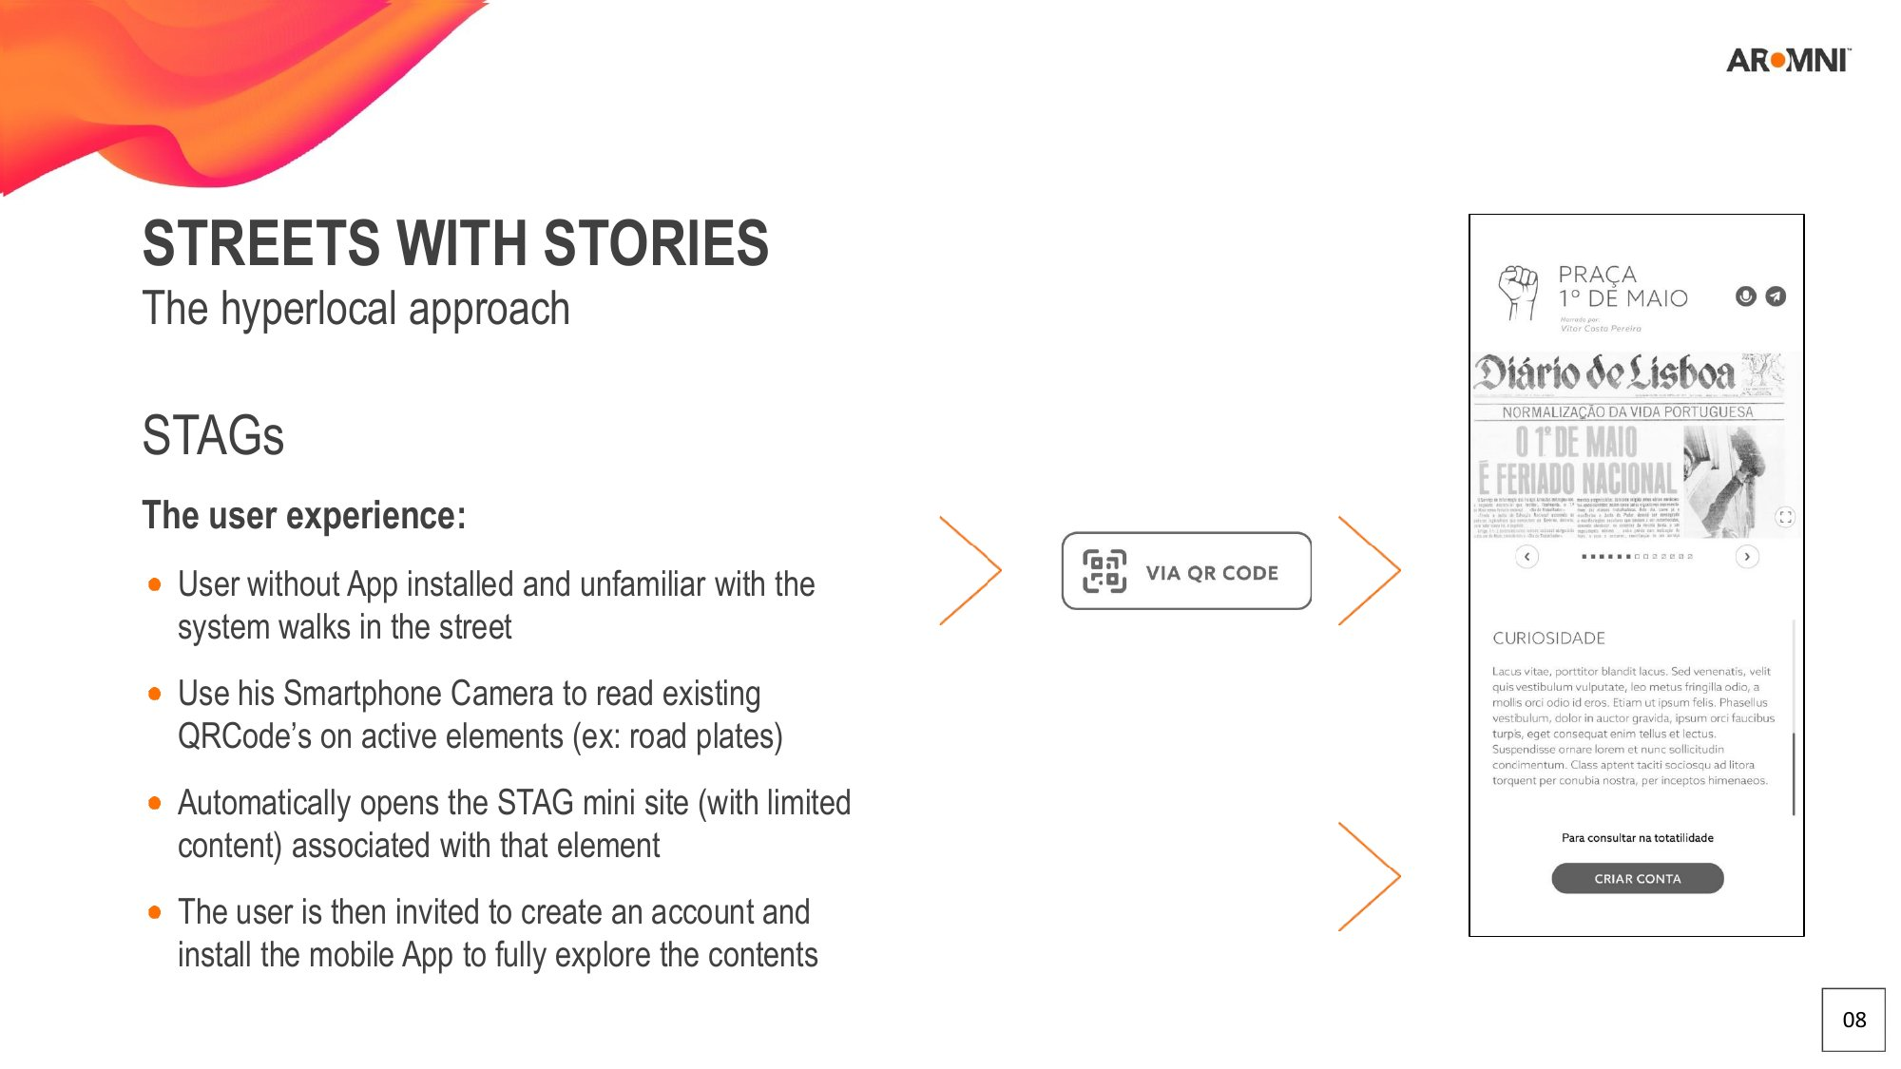
STAG interface: user interaction model showing key elements

4.2 Hypergraph Data Structures
Developed from the concept introduced in ARIA: A Browser for the Internet of Everything, Aromni's hypergraph data model provides a fundamentally new way to structure spatial information.
- Real-world entities are represented as nodes; relationships as hyperedges
- Enables efficient tagging, search, navigation, and semantic reasoning
- The structure is isomorphic to the real world, allowing multi-scale analysis and simulation
- Unlike relational databases, hypergraphs capture the richness of real-world relationships: one entity, many contexts, infinite connections

4.3 ARIA Browser — A Browser for Reality
ARIA is Aromni's mixed-reality browser, functioning as the user-facing interface to the entire Internet of Everything. It connects Real and Data Worlds through:
- Computer vision and positioning for spatial anchoring
- Natural interfaces — gesture recognition, voice commands, eye-tracking
- Blockchain registration of 'absolute tags' for verifiable, permanent spatial data
- Local discovery, hyperlocal commerce, and immersive storytelling capabilities

4.4 Platform Modules
Aromni's platform is implemented through four battle-tested modules:

Module | Function | Use Case
ARP — Augmented Reality Planogram | Smart shelf visualization & compliance | Jerónimo Martins retail project
ARDIS — Augmented Reality Digital Signage | Dynamic advertising & navigation | Retail + Cities
ARC — Augmented Reality Console | Multi-user media console unbundling physical and virtual content | Benfica / Sagres experience
ARIA Publisher (Meemoo) | Creation of structured AR content & tag networks | Smart city + storytelling

5. Vertical Applications

5.1 Smart Cities — Streets with Stories
Streets With Stories (SWS) is Aromni's flagship hyperlocal smart city application. It represents a new digitally augmented urban layer that allows cities to tell their stories through spatial tags anchored to physical locations — streets, monuments, local businesses, and hidden corners.
The platform enables cities to deliver contextual content when and where it matters most:
- Street names: The story behind the name
- Street art: Graffiti and other artistic expressions explained
- Art & monuments: Historical context layered onto physical landmarks
- Hidden secrets: Stories that only locals know
- Time traveling: 'Images from the past' — contextual street image and video collection
- Stores with a soul: Celebrating local businesses we don't want to lose
- Everyday events: Real-time micro-updates ('The bread is ready')
- Local news: Neighborhood-scale information feeds
- Virtual Post-its: Personal AR messages anchored to physical spaces
The SWS Mobile WebApp allows users to navigate through a 2D map or AR camera view, collecting stories, receiving proximity alerts, and building a personal archive of explored places. The platform is designed today for smartphones but architected for the AR glasses era — fully prepared for mass adoption of lightweight spatial computing devices.

Stakeholder | Value Proposition
Locals | Forge bonds with neighbors, understand local history, strengthen sense of belonging, boost the local economy
Visitors & Tourists | A new way to explore the city; new points of interest; access to the 'less known' history
Municipalities | Reinforce community identity; create a hyperlocal economy platform; diversify tourism demand; join a global multi-city network

5.2 Mobility — TUGA Digital Platform
Aromni's technology powers the TUGA Digital Platform, a fully integrated AR/VR ecosystem for next-generation electric vehicles. This demonstrates the depth of Aromni's platform: from vehicle design to fleet management, every touchpoint is digitally augmented.
The TUGA platform covers the full vehicle lifecycle:
- Design tools using AR/VR visualization for engineering and material testing
- Promotion tools: AR smartphone apps and immersive Meta Quest experiences
- Driving experience: Companion App, HUD, AR Glasses integration, and vehicle Main/Back screens
- Remote assistance: AI avatar assistants and digital twin-powered support
- Sustainability calculators: Carbon saver, time saver, and environmental lifecycle analysis
- MaaS platform: Fleet management, driver app, and client ride-hailing app
A CANBUS simulator was developed to implement and test all digital components while the physical vehicle is still in development — a testament to Aromni's platform-first, hardware-agnostic approach.

5.3 Retail — ARP & ARDIS
Aromni's retail applications deliver measurable commercial value:
- ARP: +15–20% planogram efficiency through AI-powered visual compliance
- ARDIS: +10% sales uplift through contextual AR product storytelling and offers
- Integration with existing ERP and store analytics systems
- Deployed with Jerónimo Martins; pipeline with major European grocery and fashion retailers

5.4 Sports & Entertainment — ARC
The ARC module merges real-time data, holographic characters, and gamified interactions for live events and venues:
- Benfica World project: AR console combining broadcast, gaming, and fan engagement
- New sponsorship and revenue formats validated in production
- Multi-user experiences supporting concurrent interactions around shared physical anchors

6. Intellectual Property Portfolio
Aromni stands on a foundation of 20+ years of YDreams R&D, resulting in a powerful IP portfolio that provides genuine competitive moats:

IP Family | Description | Status
Mixed Reality | Systems for simulating 3D virtual interactions from 2D images (cited by Apple, Disney, Microsoft) | Granted (US8624962B2)
Internet of Everything | Smart tags, hypergraph databases, ARIA browser | To be filed as full patents
Retail & AR | AR planogram compliance and digital signage | Ready to file
Augmented Mobility | AR-enabled scooters, vehicles, and multi-sensor periscopes | Ready to file

The core mixed reality patent (US8624962B2) has been cited by Apple, Disney, and Microsoft, validating the foundational importance of Aromni's technology. The broader IP portfolio covers 100+ mixed reality innovations spanning computer vision, spatial databases, UX design, storytelling, and hardware integration.

7. Competitive Landscape
Aromni occupies a unique and defensible position in the spatial computing ecosystem. While major players focus on specific layers — hardware, gaming, or enterprise twins — Aromni builds the neutral infrastructure layer that connects them all:

Company | Focus | Limitation | YSpatial Advantage
Apple / Google | Hardware & closed ecosystems | Proprietary silos | Hardware-agnostic, hyperlocal data ownership
Niantic / Snap | AR entertainment | Limited to games | Structural bridge: Real↔Data↔Virtual
PTC / Unity | Industrial digital twins | Enterprise only | Scalable to citizens and cities
YSpatial (Aromni) | Internet of Everything layer | — | Neutral, cross-sector infrastructure

The key differentiator is Aromni's infrastructure-layer position. Rather than competing in applications, Aromni provides the data model, tagging infrastructure, and AR browser upon which any vertical application can be built. This is analogous to the position of TCP/IP in the early internet — the neutral protocol that everyone uses.

8. Business Model

8.1 Revenue Streams
- Platform-as-a-Service (PaaS): SDK and API licensing to developers, enterprises, and municipalities. Tiered: Indie (€0), Professional (€500/mo), Enterprise (custom).
- Vertical SaaS: ARP for retail: €2,000–10,000/store/year + 2% rev-share on uplift. ARDIS for cities: €50,000–200,000/city/year. ARC for venues: €20,000–100,000/venue/year.
- Marketplace Economy: Transaction fees on tag-enabled commerce (2–5%); creator revenue share (70/30 split); premium content and experiences.
- Data & Analytics: Anonymized spatial intelligence for urban planning and retail optimization; subscription-based dashboards and insights.

8.2 Unit Economics (Mature State)
Metric | Target
LTV/CAC Ratio | 5–7x (SaaS benchmark: 3x)
Gross Margin | 75–85% (software-centric)
Payback Period | 12–18 months
Net Revenue Retention | 120%+ (expansion within accounts)

8.3 Financial Projections
Year | ARR | Customers | Gross Margin | EBITDA Margin
2026 | €500K | 15 | 70% | -150%
2027 | €3M | 80 | 75% | -40%
2028 | €12M | 300 | 80% | Break-even
2029 | €35M | 900 | 82% | 20%
2030 | €85M | 2,000+ | 85% | 30%

Path to Profitability: Q2 2027 at €15M ARR. Exit Benchmarks: 10–15x ARR for spatial computing platforms.

9. Investment Opportunity

Series A: €5M
Use of Funds:
- Product Development (40%): SDK v2.0, Apple Vision Pro & Meta Quest integration, marketplace MVP
- Go-to-Market (35%): Sales team expansion (retail, cities), marketing, pilot subsidies
- Operations & IP (15%): Patent filings (5 families), regulatory compliance, team scaling
- Working Capital (10%): 18-month runway

Milestones
- 6 months: SDK launched, 3 paying enterprise customers, Apple/Meta partnerships announced
- 12 months: 20 enterprise customers, €2M ARR, 5 city deployments
- 18 months: Marketplace live, 100+ creators, €5M ARR, Series B readiness

Target Valuation: €20M pre-money. Expected Ownership: 20–25%.

10. Technology Roadmap
Phase | Period | Key Milestones
I. Foundation | 2024–2026 | IP consolidation; pilot projects (Jerónimo Martins, Benfica, Alcântara); SDK v1.0
II. Expansion | 2026–2028 | SDK v2.0 launch; integration with Meta & Apple glasses; city-wide deployments
III. Scale | 2028–2030 | Marketplace activation; 100+ cities; 10+ major retail partners; ARDIS global rollout
IV. Global Layer | 2030+ | YSpatial recognized as Internet of Everything standard; cross-sector neutral infrastructure

The STAG Platform R&D programme (submitted for SIFIDE funding) will advance the platform's core architecture through eight parallel work packages: Platform Architecture, AI/ML Systems, AR/VR Browser, Video-Based Simulation, SDK & Developer Ecosystem, Blockchain Integration, Vertical Market Pilots, and Project Management.

11. Risk Mitigation
Risk | Mitigation
Hardware adoption lag | Hardware-agnostic design; mobile-first AR implementation — works today on smartphones
Competitive pressure | IP moat; first-mover in infrastructure layer; open ecosystem strategy
Regulatory (data/privacy) | Hyperlocal data ownership model; GDPR-native architecture; cities retain sovereignty over their digital twins
Market education | Pilot-driven sales; tangible ROI proof points (ARP: +10% sales uplift)
Technology risk | 20 years of YDreams R&D; proven modules in production at major brands

12. The Vision — Why This Matters
YSpatial is not building another app or gadget. We are creating the spatial infrastructure of the 21st century — the layer that will define how billions of people work, shop, travel, and experience their cities.
The Internet transformed text and data. Mobile computing transformed communication and social interaction. Spatial computing — the Internet of Everything — will transform reality itself.

The World Wide World
Just as Tim Berners-Lee gave humanity the World Wide Web, YSpatial gives it the World Wide World. Every place, every object, every experience — interconnected, discoverable, transactable. This is infrastructure investing. The returns are measured not just in exits, but in shaping how the next generation interacts with reality itself.

Aromni's mission is to build this spatial infrastructure with intelligence, empathy, and a deep commitment to data sovereignty — ensuring that the Internet of Everything remains open, human-centric, and genuinely empowering for cities, communities, and individuals alike.

