Sunday News No. 143
April 18th, 2021

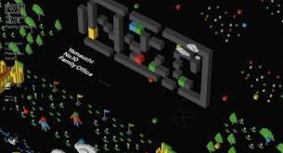
“Japan was once globally renowned for its people’s quality of unique creativity teamed with a pioneering mindset. Their innovation and inventions changed the world. But that golden era has long been gone. It seems that the quality Japanese people once possessed is overshadowed by worry and fear.

Hiroshi Yamauchi was the third president of Nintendo Co., Ltd. He was one of those people who possessed truly unique creativity and a pioneering mindset, along with foresight and the understanding of what users wanted. He took over his grandfather’s struggling playing cards production business and single-handedly transformed it into the global entertainment and play giant that Nintendo is today. And he kept going. He never stopped striving for more. He wanted to reach more people. He dreamed. He leapt. He lived.

We should all follow his example. Seeking stability only clouds your soul. Fear of failing only kills seeds of innovation. We must create a more exciting future where people feel free to dream and leap into a world of possibilities. We must create a freer future where people are eager to truly live.”

Yamauchi Family Office has a most innovative one-page Website in line with this manifesto. You should see it. You can also check the work of the company that designed it here.

Sunday News is a selection of the links posted daily by the Explora community. I can add you if you want (need to have a Facebook account). Newcomers can check previous Sunday News editions at Explora live. Read Sunday News’ First and Second-Year Highlights here.

Antonio Camara

Education
Notebooks of a system thinker

Stop taking notes- visualize with nodes

TikTok is a thriving learning community—and may be the future of education

AT&T will launch a 'digital learning platform' with Warner Media content

How to create a sense of purpose

Food
Tony’s Chocolonely tries to prove that ethical chocolate and sweet profits can co-exist

Tech keeps trying to ‘fix’ recipe sites. Food bloggers wish they’d stop

Health
What happens if you have a heart attack in your way to Mars
The blood-clot problem is multiplying and so are the theories explaining it

Sports
The World’s most valuable soccer teams

Mobility
Milo Werner talks about the challenges of shipping the Tesla Model S and X and what the Next Big Thing is

I don't get the high-speed rail thing (yet)

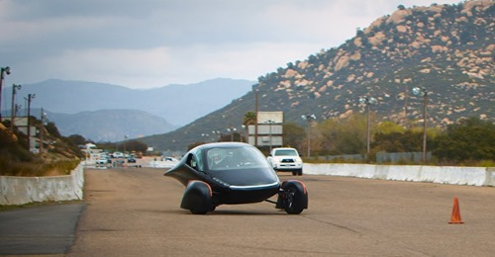
Aptera’s update

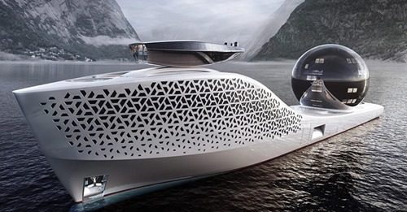
Will scientists save the World aboard this nuclear-powered 980-foot-long superyacht?

Cities, Nature and Clean Tech
These rocks made a 1000-mile trek. Did dinosaurs carry them?

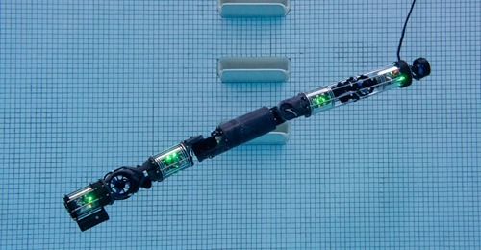
Carnegie Mellon’s latest snakebot can swim underwater

Sunrun’s CEO is selling peace of mind with her rooftop solar panels

Terracycle is on a mission to recycle everything in your life

Why has climate economics failed us?

Developing new companies
How to speak Silicon Valley: 53 essential tech-bro terms explained. A classic

Overselling sustainability reporting

How to start a new country

How I learned what “digital transformation” truly means

Patreon just raised 155 million dollars

Astranis, with a new approach to satellite internet, raises $250 million from BlackRock and others

Grab confirms record-breaking $40bn SPAC deal; archrival Gojek nears $18bn merger

Why Coinbase’s public listing is a crypto-currency coming out party

Biotech R&D startup Benchling hits $4 Billion valuation as the company starts laying groundwork for an IPO

NFT Canon and Crypto Canon, by a16z

NFTs: is the spotlight-stealing blockchain tech a cash grab or the next big thing?

Why marketplaces fail

On North Star metrics

AR/VR/AI/IoT/Quantum Computing/Bio

Mojo Vision's in-contact-lens image processor is capable of zoom, contrast enhancement, and edge detection to aid those with low vision
Mojo Vision details low-power chips for augmented reality contact lenses

Google signals smartglasses ramp up via job postings for waveguides & other AR disciplines

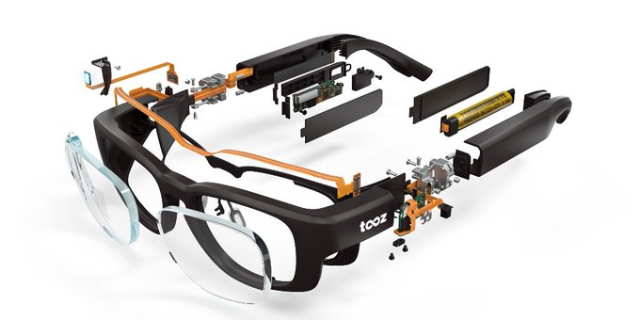
Deutsche Telekom opens early access to Tooz smartglasses via dev kit. See also Tooz technologies on Twitter

Disney developing augmented reality system capable of virtually lighting real-world objects

MetaHuman Creator will transform industries

Epic Games raises $1B for long-term metaverse plans. Read also: Gaming Platforms Move Beyond Games Into Selling Virtual Goods in the Metavers.; and The metaverse will allow you to "extend your body into architecture"
Big Tech guide to AI ethics

Love of the game. This research reminds me of the exceptional PhD work by Marta Ferraz. See https://run.unl.pt/handle/10362/19786

Robots are animals, not humans

Far out
Poem-a-day

My most memorable mentors: plants

The inside story of how the lowly PDF played the longest game in tech


This gorgeous chair was made by one of Tesla’s manufacturers

I performed at Super Bowl. You may have missed me

The frequencies of a vibrating spider web have been made into music

Tourists forced to write “sorry” 500 times for breaking lockdown in India

Google failed to put every country on Street View. Video gamers are angry

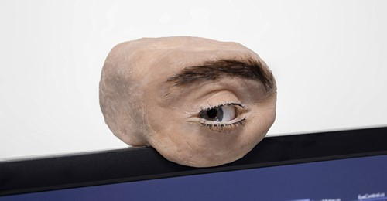
Eyecam is a creepy webcam shaped like a human eye

‘What would I do?’ Frank Gehry, 92, is too busy to retire


Single pixel of digital-only art sold for more than $1.7 million at Sotheby's

